CHAPTER-I

1. INTRODUCTION
1.1 Significance
INDUCTION MOTORS are complex electro-mechanical devices utilized in most industrial applications for the conversion of power from electrical to mechanical form. Induction motors are used worldwide as the workhorse in industrial applications. Such motors are robust machines used not only for general purposes, but also in hazardous locations and severe environments. General purpose applications of induction motors include pumps, conveyors, machine tools, centrifugal machines, presses, elevators, and packaging equipment. On the other hand, applications in hazardous locations include petrochemical and natural gas plants, while severe environment applications for induction motors include grain elevators, shredders, and equipment for coal plants. Additionally, induction motors are highly reliable, require low maintenance, and have relatively high efficiency. Moreover, the wide range of power of induction motors, which is from hundreds of watts to megawatts, satisfies the production needs of most industrial processes.
However, induction motors are susceptible to many types of fault in industrial applications. A motor failure that is not identified in an initial stage may become catastrophic and the induction motor may suffer severe damage. Thus, undetected motor faults may cascade into motor failure, which in turn may cause production shutdowns. Such shutdowns are costly in terms of lost production time, maintenance costs, and wasted raw materials.
The motor faults are due to mechanical and electrical stresses. Mechanical stresses are caused by overloads and abrupt load changes, which can produce bearing faults and rotor bar breakage. On the other hand, electrical stresses are usually associated with the power supply. Induction motors can be energized from constant frequency sinusoidal power supplies or from adjustable speed ac drives. However, induction motors are more susceptible to fault when supplied by ac drives. This is due to the extra voltage stress on the stator windings, the high frequency stator current components, and the induced bearing currents, caused by ac drives. Such electrical stresses may produce stator winding short circuits and result in a complete motor failure.
According to published surveys induction motor failures include bearing failures, inter-turn short circuits in stator windings, and broken rotor bars and end ring faults. Bearing failures are responsible for approximately two-fifths of all faults. Inter-turn short circuits in stator windings represent approximately one-third of the reported faults. Broken rotor bars and end ring faults represent around ten percent of the induction motor faults. These faults are summarized in Table 1.1
This table presents the surveys conducted by the Electric Power Research Institute (EPRI), which surveyed 6312 motors and the survey conducted by the Motor Reliability Working Group of the IEEE-IAS, which surveyed motors . motor faults. These faults are summarized in Table 1.1

Table 1.1 – Percentage of failure by component Failed Component
IEEE-IAS
Bearings Related | 44
Windings Related | 26
Rotor Related | 8
Others | 22

AC motors are generally divided into two categories, induction and synchronous motors. The most common AC motor is the "Squirrel cage motor", a type of induction motor. These have only one or more coils within which a special kind of mechanical rotor is free to rotate. There is no electrical connection to the rotor from the outside.

1.2 Construction of a Squirrel Cage Induction Motor

Figure 1.1 Squirrel cage induction motor rotor
Almost 90% of induction motors are provided with squirrel cage motor because of its very simple, robust and almost inscrutable construction. In cage construction, copper, brass, or aluminium bars are embedded in the semi closed slots, as the rotor conductors, parallel or approximately parallel to the shaft(one bar in each slot) and close to the rotor surface.
The conductors are not insulated from the core, since the rotor currents naturally follow the path of least resistance, i.e., the rotor conductors. At both ends of the rotor, the rotor conductors are all short-circuited by the continuous end rings of similar material to that of the rotor conductors. Without the rotor core, the rotor conductors and their end rings form a complete closed circuit in itself, resembling a squirrel cage, thus explaining the name.

In motors with ratings up to 100kw, the squirrel structure is formed by aluminium cast (under pressure) into the slots of the rotor. In large motors the rotor bars, instead of being cast, are wedged into the rotor slots and are then welded securely to the end rings. The slots on the rotor are always not parallel to the motor shaft but are usually skewed in order to obtain a uniform torque, reduce the magnetic locking of the stator and rotor and reduce the magnetic humming noise while running.

The squirrel cage rotor windings are perfectly symmetrical and have the advantage of being adaptable to any number of pole pairs. The distribution of current due to electro-magnetic induction in the rotor bars varies from bar to bar sinusoidal and depends upon the position and time, assuming sinusoidal distribution of radial flux density in space and also the applied voltage to be varying sinusoidal with time.

1.3 Principle of operation

The stator winding of a 3-phase induction motor is connected to 3-phase balanced supply. The flow of 3-phase currents in the 3-phase stator winding produces a rotating magnetic field. The speed of rotating field is the synchronous speed, in rpm is
$$Ns=\frac{120f}{p}………(1.1)$$
As the rotating flux wave sweeps across the stationary rotor conductors P$Ns$ times per sec and therefore emfs are induced in the rotor conductors (according to faradays law of electromagnetic induction).
As the rotor circuit is short circuited, these induced emf’s give rise to current in the rotor conductors. The interaction of these rotor currents with rotating flux wave produces torque in the rotor of a 3-phase induction motor and as a consequence, rotor begins to rotate. The setting up of the torque in induction motor can be explained in terms of Lenz’s law.
According to Lenz’s law we know that the direction of induced emf would be in such a direction that it would try to oppose the very cause for which it is due to. Because the cause producing the induced currents is the relative speed between the rotating field and the stationary rotor conductors, therefore, they circulate in such a way that a torque is produced in the rotor tending to cause it to follow the rotating magnetic field and thus reducing the relative speed.
1.4 Merits and Demerits of a Squirrel Cage Induction Motor

Merits:
- Squirrel cage induction motors are comparatively cheaper than wound rotor induction motors and are simple and rugged in construction.
- A cage rotor needs considerably less conductor material than a wound rotor, so copper loss in cage rotor is low and efficiency of a cage motor is a little more than that of a wound rotor.
- Cage motor needs no slip-rings, brushes etc., therefore its maintenance cost is low.
- Cage motor is explosion proof, because the absence of slip-rings and brushes eliminates risk of sparking.
- Cage rotor can be cooled better because of its bare end rings. Also there is more space for rotor fans.
- A cage motor has very small length of overhang, so it has low rotor overhang leakage flux. This cause’s standstill reactance low for cage rotor. So a cage rotor has more pull out torque, greater maximum power output and better operating power factor.

Demerits:
1. Since in cage rotors, rotor bars are permanently short-circuited, it is not possible to insert
any external resistance in the rotor circuit for the purpose of increasing starting torque.
Power factor is also low at the starting of cage motors.
2. No possibility of speed control.
3. Cage motors are very sensitive to fluctuations in supply voltage.
4. The total energy lost during starting of cage motor is more than in wound rotor.
1.5 Applications of a Squirrel Cage Induction Motor
For loads requiring low torques and substantially constant speeds, squirrel cage induction motor is the best choice, because of its ruggedness, simplicity, low cost and reduced maintenance charges.
Squirrel cage motors with relatively low rotor resistance (full-load slip 3 to 5%) are used for fans, centrifugal pumps, most machinery tools, wood working tools etc.
Cage motors with relatively high rotor resistance (full-load slip 3 to 7%) are used for compressors, crushers, reciprocating pumps.
Squirrel cage motors with still higher values of rotor-circuit resistance (full-load slip 7 to 16%) are used for intermittent loads like punching presses, shears, hoists, elevators etc.`
Summarization of above applications in terms of constant and variable torques is shown below:

Constant Torque applications:
- Steel mills machines, Paper machines (winder, tension reels, mill stands).
- Cement mills, rubber mills, mixers, crushers.
- Conveyors.
- Cranes and elevators cars.

Variable Torque applications:
- Centrifugal pumps.
- Centrifugal fans.
- Compressor

CHAPTER -II

2. VARIOUS TYPES OF FAULTS

The major faults of electrical machines can broadly be classified as the following : Stator faults resulting in the opening or shorting of one or more of a stator phase winding, abnormal connection of the stator windings, broken rotor bar or cracked rotor end-rings, static and/or dynamic air-gap irregularities, bent shaft (akin to dynamic eccentricity) which can result in a rub between the rotor and stator, causing serious damage to stator core and windings, shorted rotor field winding, bearing and gearbox failures.
These faults produced one or more of the symptoms as given below: unbalanced air-gap voltages and line currents, increased torque pulsations, decreased average torque, increased losses and reduction in efficiency and excessive heating. The diagnostic methods to identify the above faults may involve several different types of fields of science and technology.

2.1 Stator or Armature Faults
According to the surveys, the majority of failure related to a motor stator is breakdown of the turn-to-turn insulation. Although the induction motor can still run when some of the turns are shorted, they can consequently lead to damages on adjacent coils and a stator core, so that a ground fault can occur. To reduce repairing costs and outage time due to the stator winding fault, the early detection of inter-turn short circuit is useful.

2.1.1 Interturn faults
According to the survey, 35-40 % of induction motor failures are related to the stator winding insulation, winding-related failures are initiated by insulation failures in several turns of a stator coil within one phase. This type of fault is referred as a “stator turn fault”. A stator turn fault in a symmetrical three-phase AC machine causes a large circulating current to flow and subsequently generates excessive heat in the shorted turns. If the heat which is proportional to the square of the circulating current exceeds the limiting value the complete motor failure may occur.
An Interturn fault occurs due to the insulation breakdown between the turns of the same phase or between the parallel windings belonging to the same phase of the machine. The cause of the interturn fault is usually an overvoltage or mechanical damage of the insulation, and excess thermal or voltage stress, mechanical vibrations, or an abrasion between the stator and the rotor Interturn faults occurs in machines i.e, Transformers, Motors and Generators. Interturn fault current depends on the number of the turns shorted and fault currents will be several times higher than the rated current of the windings and thus damages the windings.

Interturn Faults are more severe on large alternators (generators), High voltage motors and power transformers. Interturn fault is most often experienced in rotating machines where multiple windings are present in the same groove. For large generators generally single winding rod per groove is designed in such cases interturn fault can occur only in the winding head region.
Interturn Fault can occur at both stator and rotor for rotating machines like generators and motors. When an interturn fault occurs on stator of a rotating machine there is a high probability that such fault can lead in to the ground fault.
When Interturn faults occur on the rotor winding following symptoms are observed:When such fault occur high excitation current is required and this is compensated by the voltage regulator,Machine runs less smoothly, because of the asymmetry of the excitation curve,Magnetization of the shaft due to asymmetrical flux and Bearing damage due to current flowing in the bearings.
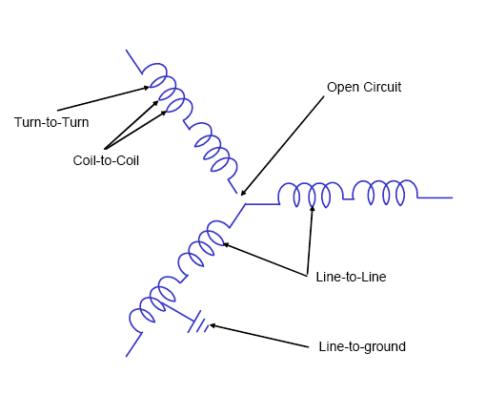

Figure 2.1: Various types of short winding faults

2.1.2 Causes for inter-turn short circuit
There are many reasons that can cause the degradation on the stator insulation. The causes can be summarized as:

1. Thermal stresses due to thermal ageing and thermal overloading: For the thermal ageing, it is a result from the operating temperature. As known, the insulation life gets half for every 10°k increase in temperature. To cope with the thermal ageing due to the temperature in the windings, reducing the operating temperature or increasing the class of insulation materials can be applied. Thermal overloading can be caused by the applied voltage variations, unbalanced phase voltage, cycling overloading, obstructed ventilation, higher ambient temperature, etc. All of these can increase the temperature and can initiate the thermal stress in the machine.
2. Electrical stresses due to voltage stresses in the windings: The voltage stress in the windings can be caused by having a void in the insulation, which can cause the partial discharge. In addition, the surge on electrical supply system can initiate the voltage stresses in the windings as well.
3. Mechanical Stresses: These stresses might be due to coil movement, which is a result from the force inside the machine, and rotor striking the stator, which is caused from many reasons, such as bearing failures, shaft deflection, rotor-to-stator misalignment, etc.
4. Environmental stresses/Contamination: the winding insulation can be deteriorated by chemicals, such as oil, moisture or dirt, etc.
5. Ageing: the winding insulation can be degraded by time.

CHAPTER- III

3. INTRODUCTION TO FOURIER ANALYSIS

One of the major Signal Processing tools is the Fourier analysis, which has different forms like Fourier series, Fourier Transform, Discrete Fourier Transform, and so on. Fourier analysis methods use orthogonal sets of functions in order to expand a given periodic function into an infinite series. While a large number of orthogonal sets exist, the Fourier analysis form which is commonly utilized makes use of the cosine and sine functions. However, for non-periodic time-varying signals, the above mentioned method has several inconveniences. To a certain extent, these could be overcome by the application of different windowing techniques leading to the Short-Time-Fourier Transforms. But these have also their own limitations. An alternative method is to use wavelets.
3.1 Fourier Analysis
Fourier's representation of functions as a superposition of sines and cosines has become ubiquitous for both the analytic and numerical solution of differential equations and for the analysis and treatment of communication signals. Fourier and wavelet analysis have some very strong links.
3.2 Fourier Transform (FT)
A general transform equation can be written as :
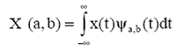 ------------------- (3.1)
The signal to be processed is given as x(t). Depending on the function ψa,b(t) chosen, one gets different transforms. In order to evaluate the integral, certain conditions have to be imposed on this function. In this project, we shall consider only three such transforms and these are the Fourier Transform, Fast Fourier Transform and the Wavelet Transform
If the FT of a signal in time domain is taken, the frequency-amplitude representation of that signal is obtained. In other words, we now have a plot with one axis being the frequency and being the amplitude. This plot tells us how much of each frequency exists in our signal. The frequency axis starts from zero, and goes up to infinity.
For every frequency, we have an amplitude value. Its mathematical background is,The function ψa,b(t) is given by
---------------------- (3.2)
where f is the frequency, and the length of the window is infinite since the basis functions are the sine and the cosine functions.
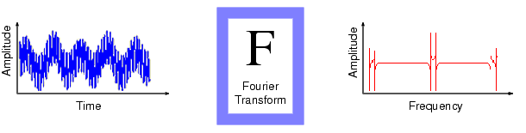
Fig.3.1 Fourier Transform of a given signal
FT give the frequency information of the signal, which means that it tells us how much of each frequency exists in the signal, but it does not tells us when in tine this frequency components exist. This information is not required when the signal is so called stationary.
Signals whose frequency content do not change in time are called stationary signals. In other words, the frequency content of stationary signals do not change in time. In this case, one does not need to know at what times frequency components exist, since all frequency components exist at all time.
A signal whose frequency constantly changes in time, this signal is known as a “chirp” signal. This is a non-stationary signal. FT gives the spectral content of the signal, but it gives no information regarding varying time those spectral components appear. Therefore FT is not a suitable technique for non stationary signal, with one exception.
FT can be used for non-stationary signals, if we are only interested in what spectral components exist in the signal, but not interested where these occur. However, if these information needed, i.e., if we want to know, what spectral component occur at what time (interval), then FT is not the right transform to use .
Therefore when the time localization of the spectral components is needed, a Transform giving the time frequency representation of the signal is needed. This solution is achieved by ‘wavelet transforms’.
Wavelet transform is capable of providing the time and frequency information simultaneously, hence giving a time-frequency representation of the signal. There is an issue, called “uncertainty principle”, which states that, we cannot exactly know what frequency exists at what time instance, but we can only know what frequency bands exist at what time intervals.
The frequency and time information of a signal at some certain point in the time frequency plane cannot be know. In other words: we cannot know what spectral component exists at any given time instant. The best we can do is to investigate what spectral component exists at any given interval of time. This is a problem of resolution, and it is the main reason why researchers have switched to WT from STFT.STFT gives a fixed resolution at all time, whereas WT gives a variable resolution as follows:
Higher frequencies are better resolved in time, and lower frequencies are better resolved in frequency. This means that, a certain high frequency component can be located better in time (with less relative error) than a low frequency component. On the contrary, a low frequency component can be located better in frequency compared to high frequency component.
Most of the signals in practice, are TIME-DOMAIN signals in their raw format. That is, whatever that signal is measuring, is a function of time. In other words, when we plot the signal one of the axes is time (independent variable), and the other (dependent variable) is usually the amplitude. When we plot time domain signals, we obtain a time-amplitude representation of the signal. This representation is not always the best representation of the signal for most signal processing related applications. In many cases, the most distinguished information is hidden in the frequency content of the signal. The frequency SPECTRUM of a signal is basically the frequency components (spectral components) of that signal. The frequency spectrum of a signal shows what frequencies exist in the signal.
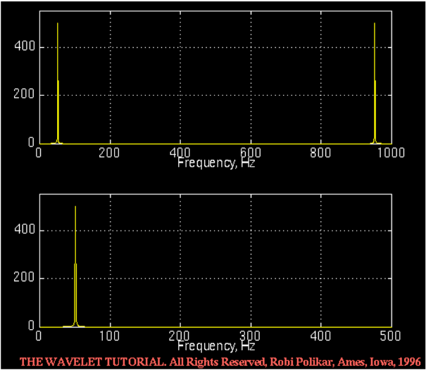
The frequency is measured in cycles/second, or with a more common name, in "Hertz". For example the electric power we use in our daily life in the US is 60 Hz (50 Hz elsewhere in the world). This means that if you try to plot the electric current, it will be a sine wave passing through the same point 50 times in 1 second. We measure frequency by using Fourier transform. If the FT of a signal in time domain is taken, the frequency-amplitude representation of that signal is obtained. In other words, we now have a plot with one axis being the frequency and the other being the amplitude. This plot tells us how much of each frequency exists in our signal. For example, if we take the FT of the electric current that we use in our houses, we will have one spike at 50 Hz, and nothing elsewhere, since that signal has only 50 Hz frequency component, No other signal. The following shows the FT of the 50 Hz signal:

Fig. 3.2 FT of the 50 Hz signal
Why do we need the frequency information?
A pathological condition can sometimes be diagnosed more easily when the frequency content of the signal is analyzed. This, of course, is only one simple example why frequency content might be useful. Today Fourier transforms are used in many different areas including all branches of engineering.
Signals whose frequency content do not change in time are called stationary signals. In this case, one does not need to know at what times frequency components exist since all frequency components exist at all times !!! . For example the following signal.
x(t)=cos(2*pi*10*t)+cos(2*pi*25*t)+cos(2*pi*50*t)+cos(2*pi*100*t)........(3.3)
is a stationary signal, because it has frequencies of 10, 25, 50, and 100 Hz at any given time

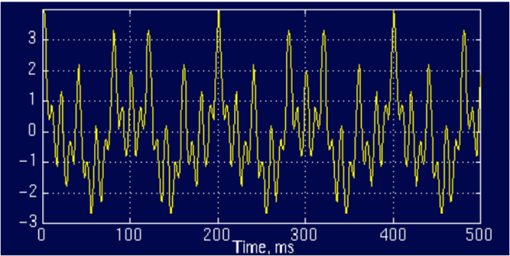

Fig.3.3 Stationary Signal
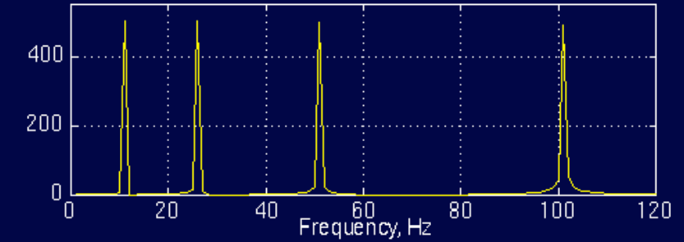
And the following is its FT:

Fig.3.4 FT of Stationary Signal
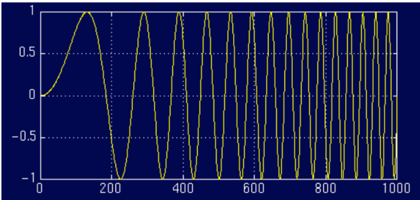
Consider the following non stationary signal

Fig.3.5 Non- Stationary Signal
These Figure plots a signal with four different frequency components at four different time intervals, hence a non-stationary signal. The interval 0 to 300 ms has a 100 Hz sinusoid, the interval 300 to 600 ms has a 50 Hz sinusoid, the interval 600 to 800 ms has a 25 Hz sinusoid, and finally the interval 800 to 1000 ms has a 10 Hz sinusoid.

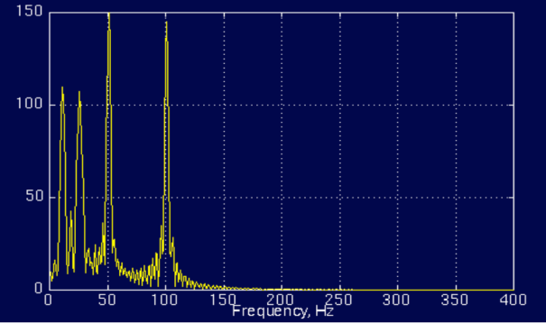
And the following is its FT:

Fig.3.6 FT of Non- Stationary Signal
The little ripples at this time; they are due to sudden changes from one frequency component to another, which have no significance. The amplitudes of higher frequency components are higher than those of the lower frequency ones. This is due to fact that higher frequencies last longer (300 ms each) than the lower frequency components (200 ms each). Both of them show four spectral components at exactly the same frequencies, i.e., at 10, 25, 50, and 100 Hz. Other than the ripples, and the difference in amplitude (which can always be normalized), the two spectrums are almost identical, although the corresponding time-domain signals are not even close to each other. Both of the signals involves the same frequency components, but the first one has these frequencies at all times, how the spectrums of two entirely different signals look very much alike because that the FT gives the spectral content of the signal, but it gives no information regarding where in time those spectral components appear.
Drawback
Therefore, FT is not a suitable technique for non-stationary signal, with one exception. So the FT gives what frequency components (spectral components) exist in the signal. Nothing more, nothing less.
3.3 Discrete Fourier Transform
The discrete Fourier transform (DFT) estimates the Fourier transform of a function from a finite number of its sampled points. The sampled points are supposed to be typical of what the signal looks like at all other times. The DFT has symmetry properties almost exactly the same as the continuous Fourier transform. In addition, the formula for the inverse discrete Fourier transform is easily calculated using the one for the discrete Fourier transform because the two formulas are almost identical. DFTs with a million points are common in many applications. Modern signal and image processing applications would be impossible without an efficient method for computing the DFT.
Direct application of the definition of the DFT to a data vector of length n requires n multiplications and n additions a total of 2n² floating-point operations. This does not include the generation of the powers of the complex nth root of unity ω. To compute a million-point DFT, a computer capable of doing one multiplication and addition every microsecond requires a million seconds, or about 11.5 days.
3.3.1 Periodicity
The DTFT, X(e^{jΩ} )is periodic. One period extends from f = 0 to fs, where fs is the sampling frequency. Taking advantage of this redundancy, The DFT is only defined in the region between 0 and fs.
3.3.2 Symmetry
When the region between 0 and fs is examined, it can be seen that there is even symmetry around the center point, 0:5fs, the Nyquist frequency. This symmetry adds redundant information. Figure 3.7 shows the DFT of a cosine with a frequency one tenth the sampling frequency. Note that the data between 0:5fs and fs is a mirror image of the data between 0 and 0:5fs.
Fig 3.7 Plot showing the symmetry of a DFT

3.4 Windowed Fourier Transform
If f (t) is a non periodic signal, the summation of the periodic functions, sine and cosine, does not accurately represent the signal. You could artificially extend the signal to make it periodic but it would require additional continuity at the endpoints. The windowed Fourier transform (WFT) is one solution to the problem of better representing the non periodic signal. The WFT can be used to give information about signals simultaneously in the time domain and in the frequency domain.
With the WFT, the input signal f (t) is chopped up into sections, and each section is analyzed for its frequency content separately. If the signal has sharp transitions, we window the input data so that the sections converge to zero at the endpoints. This windowing is accomplished via a weight function that places less emphasis near the interval's endpoints than in the middle. The effect of the window is to localize the signal in time.
3.5 FFT (Fast Fourier Transform)
The FFT is a faster version of the Discrete Fourier Transform (DFT). To approximate a function by samples, and to approximate the Fourier integral by the discrete Fourier transform, requires applying a matrix whose order is the number sample points n: Since multiplying an nxn matrix by a vector costs on the order of n² arithmetic operations, the problem gets quickly worse as the number of sample points increases. However, if the samples are uniformly spaced, then the Fourier matrix can be factored into a product of just a few sparse matrices, and the resulting factors can be applied to a vector in a total of order n log n arithmetic operations. This is the so-called fast Fourier transform or FFT. The FFT utilizes some clever algorithms to do the same thing as the DTF, but in much less time. Fast Fourier Transform (FFT) algorithms have computational complexity O(n log n) instead of O(n²). If n is a power of 2, a one-dimensional FFT of length n requires less than 3n log₂ n floating-point operations (times a proportionality constant). For n = 220, that is a factor of almost 35,000 faster than 2n².
Review of Transforms:
The Laplace transform is used to to find a pole/zero representation of a continuous-time signal or system, x(t), in the s-plane. Similarly, The z transform is used to find a pole/zero representation of a discrete-time signal or system, x[n], in the z-plane. The continuous-time Fourier transform (CTFT) can be found by evaluating the Laplace transform at s = jω. The discrete-time Fourier transform (DTFT) can be found by evaluating the z transform at z = e^{jΩ}
3.5.1 Matlab and the FFT
Matlab's FFT function is an effective tool for computing the discrete Fourier transform of a signal.
The following code examples will help you to understand the details of using the FFT function.
Example 1: The typical syntax for computing the FFT of a signal is FFT(x,N) where x is the signal, x[n], you wish to transform, and N is the number of points in the FFT. N must be at least as large as the number of samples in x[n]. To demonstrate the effect of changing the value of N, synthesize a cosine with 30 samples at 10 samples per period.
n = [0:29];
x = cos(2*pi*n/10);
Define 3 different values for N. Then take the transform of x[n] for each of the 3 values that were defined. The abs function finds the magnitude of the transform, as we are not concerned with distinguishing between real and imaginary components.
N1 = 64;
N2 = 128;
N3 = 256;
X1 = abs(fft(x,N1));
X2 = abs(fft(x,N2));
X3 = abs(fft(x,N3));
The frequency scale begins at 0 and extends to N = 1 for an N-point FFT. We then normalize the scale so that it extends from 0 to 1-1/N .
F1 = [0 : N1 - 1]/N1;
F2 = [0 : N2 - 1]/N2;
F3 = [0 : N3 - 1]/N3;
Plot each of the transforms one above the other.
subplot(3,1,1)
plot(F1,X1,'-x'),title('N = 64'),axis([0 1 0 20])
subplot(3,1,2)
plot(F2,X2,'-x'),title('N = 128'),axis([0 1 0 20])
subplot(3,1,3)
plot(F3,X3,'-x'),title('N = 256'),axis([0 1 0 20])
Upon examining the plot (shown in figure 2) one can see that each of the transforms adheres to the same shape, differing only in the number of samples used to approximate that shape. What happens if N is the same as the number of samples in x[n]? To find out, set N1 = 30. What does the resulting plot look like? Why does like this?

Figure3.8 FFT of a cosine for N = 64, 128, and 256
Example 2: In the the last example the length of x[n] was limited to 3 periods in length.
Now, let's choose a large value for N (for a transform with many points), and vary the number of repetitions of the fundamental period.
n = [0:29];
x1 = cos(2*pi*n/10); % 3 periods
x2 = [x1 x1]; % 6 periods
x3 = [x1 x1 x1]; % 9 periods
N = 2048;
X1 = abs(fft(x1,N));
X2 = abs(fft(x2,N));
X3 = abs(fft(x3,N));
F = [0:N-1]/N;
subplot(3,1,1)
plot(F,X1),title('3 periods'),axis([0 1 0 50])
subplot(3,1,2)
plot(F,X2),title('6 periods'),axis([0 1 0 50])
subplot(3,1,3)
plot(F,X3),title('9 periods'),axis([0 1 0 50])
The previous code will produce three plots. The first plot, the transform of 3 periods of a cosine, looks like the magnitude of 2 sincs with the center of the first sinc at 0:1fs and the second at 0:9fs.
Figure 3.9: FFT of a cosine of 3, 6, and 9 periods

But I thought a sinusoid transformed to an impulse, why do we have sincs in the frequency domain?

When the FFT is computed with an N larger than the number of samples in x[n], it fills in the samples after x[n] with zeros. Example 2 had an x[n] that was 30 samples long, but the FFT had an N = 2048. When Matlab computes the FFT, it automatically fills the spaces from n = 30 to n = 2047 with zeros. This is like taking a sinusoid and multiplying it with a rectangular box of length 30. A multiplication of a box and a sinusoid in the time domain should result in the convolution of a sinc with impulses in the frequency domain. Furthermore, increasing the width of the box in the time domain should increase the frequency of the sinc in the frequency domain. The previous Matlab experiment supports this conclusion.

3.5.2 Spectrum Analysis with the FFT and Matlab:
The FFT does not directly give you the spectrum of a signal. As we have seen with the last two experiments, the FFT can vary dramatically depending on the number of points (N) of the FFT, and the number of periods of the signal that are represented. There is another problem as well. The FFT contains information between 0 and fs, however, we know that the sampling frequency must be at least twice the highest frequency component. Therefore, the signal's spectrum should be entirely below fs/2 , the Nyquist frequency.
Recall also that a real signal should have a transform magnitude that is symmetrical for for positive and negative frequencies. So instead of having a spectrum that goes from 0 to fs, it would be more appropriate to show the spectrum from –fs/2 to fs/2.
This can be accomplished by using Matlab's fftshift function as the following code demonstrates.
n = [0:149];
x1 = cos(2*pi*n/10);
N = 2048;
X = abs(fft(x1,N));
X = fftshift(X);
F = [-N/2:N/2-1]/N;
plot(F,X),
xlabel('frequency / f _s')
Figure 3.10: Approximate Spectrum of a Sinusoid with the FFT
3.6 Short Time Fourier Transform (STFT)
If the region where the signal can be assumed to be stationary is too small, then we look at that signal from narrow windows, narrow enough that the portion of the signal seen from these windows are indeed stationary. This approach of researchers ended up with a revised version of the FT, so-called: The Short Time Fourier Transform (STFT). In mathematical ,the function ψa,b(t) is given by
---------------------- (3.4)
Where a = f is the frequency , ψ(t) is a window of finite width ,is a window of finite width, and b is the window translation parameter. This means that ψ (t-b) is a time-shifted version of, ψ(t) of and is of finite duration.
There is only a minor difference between STFT and FT. In STFT, the signal is divided into small enough segments where these segments (portions) of the signal can be assumed to be stationary. for this purpose, a window function “W” is chosen. The width of this window must be equal to the segment of the signal where its stationary is valid. This window function is first located to the very beginning of the signal.
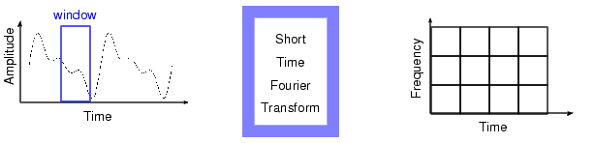
Fig.3.11 STFT of a given signal
In STFT, the window is of finite length, thus I covers only a portion of the signal, which causes the frequency resolution to get poorer .i.e., we no longer know the exact frequency components that exist in the signal, but we only know a band of frequencies that exist. In FT, the kernel function exp (jωt), allows obtaining perfect frequency resolution, because the kernel is itself is a window of infinite length. In STFT the window is finite length, and we no longer have perfect frequency resolution. If we make the length of the window in STFT infinite, just like as it is in the FT, we lose all the time information and basically end up with FT instead of STFT.
If we use a window of infinite length, we get the FT, which gives perfect frequency resolution, but no time information. Further more in order to obtain the stationary, we have to have a short enough window, the better the time resolution and better the assumption of stationary, but poorer the frequency resolution:
Narrow window → good time resolution and poor frequency resolution.
Wide window → good frequency resolution and poor time resolution.
Applications:
The Fourier transform has many applications, in fact any field of physical science that uses sinusoidal signals, such as engineering, physics, applied mathematics, and chemistry, will make use of Fourier series and Fourier transforms. Here are some examples from physics, engineering, and signal processing.
- Communications
- Astronomy
- Geology
- Physics

CHAPTER - IV

4. WAVELET ANALYSIS

4.1 Introduction to Wavelets:
Wavelets are mathematical functions that cut up data into different frequency components, and then study each component with a resolution matched to its scale. They have advantages over traditional Fourier methods in analyzing physical situations where the signal contains discontinuities and sharp spikes. Wavelets were developed independently in the fields of mathematics, quantum physics, electrical engineering, and seismic geology. Interchanges between these fields during the last ten years have led to many new wavelet applications such as image compression, turbulence, human vision, radar, and earthquake prediction. This paper introduces wavelets to the interested technical person outside of the digital signal processing field. I describe the history of wavelets beginning with Fourier, compare wavelet transforms with Fourier transforms, state properties and other special aspects of wavelets, and finish with some interesting applications such as image compression, musical tones, and de-noising noisy data.
4.2 Wavelets Overview
The fundamental idea behind wavelets is to analyze according to scale. Indeed, some researchers in the wavelet field feel that, by using wavelets, one is adopting a whole new mindset or perspective in processing data.
Wavelets are functions that satisfy certain mathematical requirements and are used in representing data or other functions. This idea is not new. Approximation using superposition of functions has existed since the early 1800's, when Joseph Fourier discovered that he could superpose sines and cosines to represent other functions. However, in wavelet analysis, the scale that we use to look at data plays a special role. Wavelet algorithms process data at different scales or resolutions. If we look at a signal with a large “window," we would notice gross features. Similarly, if we look at a signal with a small “window," we would notice small features. The result in wavelet analysis is to see both the forest and the trees, so to speak.
This makes wavelets interesting and useful. For many decades, scientists have wanted more appropriate functions than the sines and cosines which comprise the bases of Fourier analysis, to approximate choppy signals. By their definition, these functions are non-local (and stretch out to infinity).
They therefore do a very poor job in approximating sharp spikes. But with wavelet analysis, we can use approximating functions that are contained neatly in finite domains. Wavelets are well-suited for approximating data with sharp discontinuities.

The wavelet analysis procedure is to adopt a wavelet prototype function, called an analyzing wavelet or mother wavelet. Temporal analysis is performed with a contracted, high-frequency version of the prototype wavelet, while frequency analysis is performed with a dilated, low-frequency version of the same wavelet. Because the original signal or function can be represented in terms of a wavelet expansion (using coefficients in a linear combination of the wavelet functions), data operations can be performed using just the corresponding wavelet coefficients. And if you further choose the best wavelets adapted to your data, or truncate the coefficients below a threshold, your data is sparsely represented. This sparse coding makes wavelets an excellent tool in the field of data compression.

Other applied fields that are making use of wavelets include astronomy, acoustics, nuclear engineering, sub-band coding, signal and image processing, neurophysiology, music, magnetic resonance imaging, speech discrimination, optics, fractals, turbulence, earthquake-prediction, radar, human vision, and pure mathematics applications such as solving partial differential equations.
4.3 Wavelet
The transform of a signal is just another form of representing the signal. It does not change the information content present in the signal. The Wavelet Transform provides a time-frequency representation of the signal. It was developed to overcome the short coming of the Short Time Fourier Transform (STFT), which can also be used to analyze non-stationary signals. While STFT gives a constant resolution at all frequencies, the Wavelet Transform uses multi-resolution technique by which different frequencies are analyzed with different resolutions.
A wave is an oscillating function of time or space and is periodic. In contrast, wavelets are localized waves. They have their energy concentrated in time or space and are suited to analysis of transient signals. While Fourier Transform and STFT use waves to analyze signals, the Wavelet Transform uses wavelets of finite energy.

A wavelet is a mathematical function used to divide a given function or continuous-time signal into different frequency components and study each component with a resolution that matches its scale. A wavelet transform is the representation of a function by wavelets. The wavelets are scaled and translated copies (known as "daughter wavelets") of a finite-length or fast-decaying oscillating waveform (known as the "mother wavelet"). Wavelet transforms have advantages over traditional Fourier transforms for representing functions that have discontinuities and sharp peaks, and for accurately deconstructing and reconstructing finite, non-periodic and/or non-stationary signals.

“A wavelet is a waveform of effectively limited duration that has an average value of zero”
4.1(a), 4.1(b) Demonstration of a Wave and a Wavelet

The wavelet analysis is done similar to the STFT analysis. The signal to be analyzed is multiplied with a wavelet function just as it is multiplied with a window function in STFT, and then the transform is computed for each segment generated. However, unlike STFT, in Wavelet Transform, the width of the wavelet function changes with each spectral component. The Wavelet Transform, at high frequencies, gives good time resolution and poor frequency resolution, while at low frequencies; the Wavelet Transform gives good frequency resolution and poor time resolution.
4.4 Historical Perspective
In the history of mathematics, wavelet analysis shows many different origins. Much of the work was performed in the 1930s, and, at the time, the separate efforts did not appear to be parts of a coherent theory.

4.4.1 PRE-1930
Before 1930, the main branch of mathematics leading to wavelets began with Joseph Fourier (1807) with his theories of frequency analysis, now often referred to as Fourier synthesis. He asserted that any 2periodic function f(x) is the sum of its Fourier series.
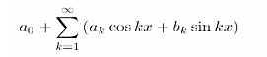............................ (4.1)
The coefficients a₀, a_{k} and b_{k} are calculated by
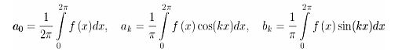....... (4.2)

Fourier's assertion played an essential role in the evolution of the ideas mathematicians had about the functions. He opened up the door to a new functional universe.

After 1807, by exploring the meaning of functions, Fourier series convergence, and orthogonal systems, mathematicians gradually were led from their previous notion of frequency analysis to the notion of scale analysis. That is, analyzing f(x) by creating mathematical structures that vary in scale. How? Construct a function, shift it by some amount, and change its scale. Apply that structure in approximating a signal. Now repeat the procedure. Take that basic structure, shift it, and scale it again. Apply it to the same signal to get a new approximation. And so on. It turns out that this sort of scale analysis is less sensitive to noise because it measures the average fluctuations of the signal at different scales.

The first mention of wavelets appeared in an appendix to the thesis of A. Haar (1909). One property of the Haar wavelet is that it has compact support, which means that it vanishes outside of a finite interval. Unfortunately, Haar wavelets are not continuously differentiable which somewhat limits their applications.

4.4.2 THE 1930S

In the 1930s, several groups working independently researched the representation of functions using scale-varying basis functions. Understanding the concepts of basis functions and scale-varying basis functions is key to understanding wavelets; the sidebar below provides a short detour lesson for those interested.

By using a scale-varying basis function called the Haar basis function Paul Levy, a 1930s physicist, investigated Brownian motion, a type of random signal. He found the Haar basis function superior to the Fourier basis functions for studying small complicated details in the Brownian motion.

Another 1930s research effort by Little wood, Paley, and Stein involved computing the energy of a function f(x):
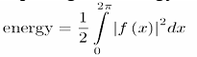………………………. (4.3)
The computation produced different results if the energy was concentrated around a few points or distributed over a larger interval. This result disturbed the scientists because it indicated that energy might not be conserved. The researchers discovered a function that can vary in scale and can conserve energy when computing the functional energy. Their work provided David Marr with an effective algorithm for numerical image processing using wavelets in the early 1980s.

Basis Functions

It is simpler to explain a basis function if we move out of the realm of analog (functions) and into the realm of digital (vectors) (*). Every two-dimensional vector (x; y) is a combination of the vector (1; 0) and (0; 1): These two vectors are the basis vectors for (x; y): Why? Notice that x multiplied by (1; 0) is the vector (x; 0); and y multiplied by (0; 1) is the vector (0; y): The sum is (x; y): The best basis vectors have the valuable extra property that the vectors are perpendicular, or orthogonal to each other. For the basis (1; 0) and (0; 1); this criteria is satisfied.

Now let's go back to the analog world, and see how to relate these concepts to basis functions. Instead of the vector (x; y); we have a function f(x): Imagine that f(x) is a musical tone, say the note A in a particular octave. We can construct A by adding sines and cosines using combinations of amplitudes and frequencies. The sines and cosines are the basis functions in this example, and the elements of Fourier synthesis. For the sines and cosines chosen, we can set the additional requirement that they be orthogonal. How? By choosing the appropriate combination of sine and cosine function terms whose inner product add up to zero. The particular set of functions that are orthogonal and that construct f(x) are our orthogonal basis functions for this problem.

Scale-varying Basis Functions
A basis function varies in scale by chopping up the same function or data space using different scale sizes. For example, imagine we have a signal over the domain from 0 to 1. We can divide the signal with two step functions that range from 0 to 1/2 and 1/2 to 1. Then we can divide the original signal again using four step functions from 0 to 1/4, 1/4 to 1/2, 1/2 to 3/4, and 3/4 to 1. And so on. Each set of representations code the original signal with a particular resolution or scale.

4.4.3 1960-1980
Between 1960 and 1980, the mathematicians Guido Weiss and Ronald R.Coifman studied the simplest elements of a function space, called atoms, with the goal of finding the atoms for a common function and finding the \assembly rules" that allow the reconstruction of all the elements of the function space using these atoms. In 1980, Grossman and Morlet, a physicist and an engineer, broadly defined wavelets in the context of quantum physics. These two researchers provided a way of thinking for wavelets based on physical intuition.
4.4.4 POST-1980
In 1985, Stephane Mallat gave wavelets an additional jump-start through his work in digital signal processing. He discovered some relationships between quadrature mirror filters, pyramid algorithms, and orthonormal wavelet bases (more on these later). Inspired in part by these results, Y. Meyer constructed the first non-trivial wavelets. Unlike the Haar wavelets, the Meyer wavelets are continuously differentiable; however they do not have compact support. A couple of years later, Ingrid Daubechies used Mallat's work to construct a set of wavelet orthonormal basis functions that are perhaps the most elegant, and have become the cornerstone of wavelet applications today.

4.5 Transform Techniques:
Mathematical transformations are applied to signals to obtain further information from that is not readily available in the raw signal. Most of the signals in practice are time-domain signals in their raw format. That is, whatever that signal is measuring, is a function of time. In other words, when we plot the signal one of the axis is time (independent variable), and the other (dependent variable) is usually the amplitude. When we plot time domain signal, we obtain a time-amplitude representation of the signal. This representation is not always the best representation of the signal for most signal processing related applications. In many cases, the most distinguished information is hidden in the frequency content of the signal. The frequency spectrum of a signal is basically the frequency components (spectral components) of that signal. The frequency spectrum of a signal shows what frequencies exist in the signal.

4.5.1 Wavelet Transform
Wavelet analysis represents the next logical step: a windowing technique with variable-sized regions. Wavelet analysis allows the use of long time intervals where we want more precise low-frequency information, and shorter regions where we want high-frequency information.
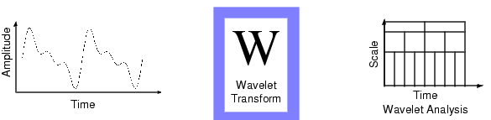
Fig.4.2 Wavelet Analysis of a given signal

Here's what this looks like in contrast with the time-based, frequency-based, and STFT views of a signal:

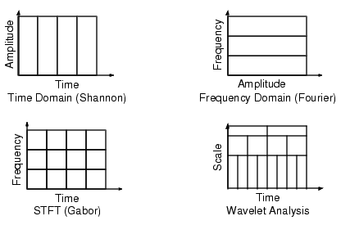
Fig.4.3 Comparison of Time-Domain, FT, STFT and WT

4.6 Wavelet Transform VS Fourier Transform
4.6.1 Similarities Between Fourier and wavelet transforms
The fast Fourier transform (FFT) and the discrete wavelet transform (DWT) are both linear operations that generate a data structure that contains log₂ n segments of various lengths, usually filling and transforming it into a different data vector of length 2n. The mathematical properties of the matrices involved in the transforms are similar as well. The inverse transform matrix for both the FFT and the DWT is the transpose of the original. As a result, both transforms can be viewed as a rotation in function space to a different domain. For the FFT, this new domain contains basis functions that are sines and cosines. For the wavelet transform, this new domain contains more complicated basis functions called wavelets, mother wavelets, or analyzing wavelets.
Both transforms have another similarity. The basis functions are localized in frequency, making mathematical tools such as power spectra (how much power is contained in a frequency interval) and scale grams useful at picking out frequencies and calculating power distributions.
4.6.2 Dissimilarities Between Fourier And Wavelet Transforms
The most interesting dissimilarity between these two kinds of transforms is that individual wavelet functions are localized in space. Fourier sine and cosine functions are not. This localization feature, along with wavelets' localization of frequency, makes many functions and operators using wavelets “sparse" when transformed into the wavelet domain. This sparseness, in turn, results in a number of useful applications such as data compression, detecting features in images, and removing noise from time series.

One way to see the time-frequency resolution differences between the Fourier transform and the wavelet transform is to look at the basis function coverage of the time-frequency plane. Figure shows a windowed Fourier transform, where the window is simply a square wave. The square wave window truncates the sine or cosine function to fit a window of a particular width. Because a single window is used for all frequencies in the WFT, the resolution of the analysis is the same at all locations in the time-frequency plane.

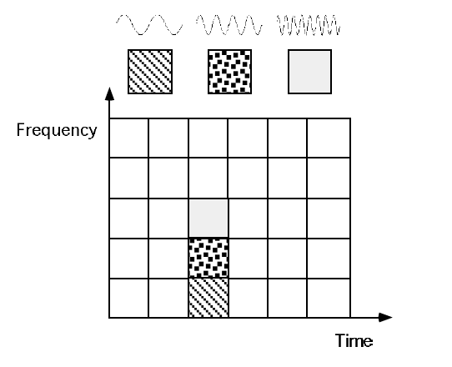
Fig.4.4 Fourier basis functions, time-frequency tiles, and coverage of the time frequency plane.

An advantage of wavelet transforms is that the windows vary. In order to isolate signal discontinuities, one would like to have some very short basis functions. At the same time, in order to obtain detailed frequency analysis, one would like to have some very long basis functions. A way to achieve this is to have short high-frequency basis functions and long low-frequency ones. This happy medium is exactly what you get with wavelet transforms. Figure shows the coverage in the time-frequency plane with one wavelet function, the Daubechies wavelet.

One thing to remember is that wavelet transforms do not have a single set of basis functions like the Fourier transform, which utilizes just the sine and cosine functions. Instead, wavelet transforms have an infinite set of possible basis functions. Thus wavelet analysis provides immediate access to information that can be obscured by other time-frequency methods such as Fourier analysis

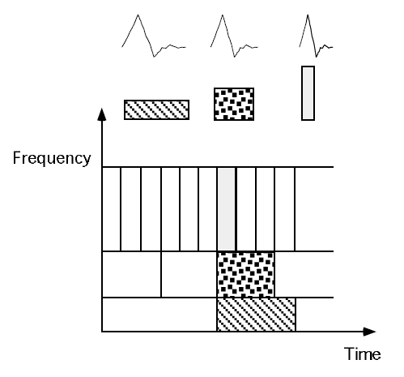

Fig.4.5 Daubechies wavelet basis functions, time-frequency tiles, and coverage of the time-frequency plane.

4.7 Types of Wavelet Transforms
Wavelet transforms are broadly divided into two classes.

- CONTINUOUS WAVELET TRANSFORM (CWT)
- DISCRETE WAVELET TRANSFORM (DWT)

4.7.1 Continuous Wavelet Transform
Mathematically, the process of Fourier analysis is represented by the Fourier transform

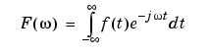.......................................... (4.4)
which is the sum over all time of the signal f(t) multiplied by a complex exponential. (Recall that a complex exponential can be broken down into real and imaginary sinusoidal components.)

The results of the transform are the Fourier coefficients F (ω), which when multiplied by a sinusoid of frequency ω yield the constituent sinusoidal components of the original signal. Graphically, the process looks like
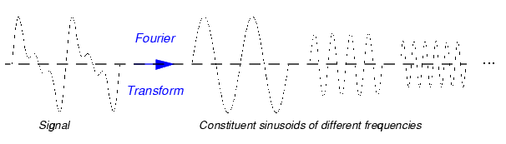
Fig.4.6 Fourier Transform of a given signal.
Similarly, the continuous wavelet transform (CWT) is defined as the sum over all time of the signal multiplied by scaled, shifted versions of the wavelet functionΨ.
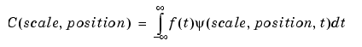 ............. (4.5)
The definition of continuous wavelet transform (CWT) for a given signal x(t) with respect to a mother wavelet (t) is:
.................................... (4.6)
Where a is the scale factor and b is the translation factor.
For CWT, t, a, b are all continuous. Unlike Fourier transform, the wavelet transform requires selection of a mother wavelet for different applications. One of the most popular mother wavelets found for power system transient analysis in the literature is Biorthogonal wavelet family. In this paper, the bior(5.5) wavelet is selected as the mother wavelet for detecting the short duration, fast decaying fault generated transient signals.
The results of the CWT are many wavelet coefficients C, which are a function of scale and position. Multiplying each coefficient by the appropriately scaled and shifted wavelet yields the constituent wavelets of the original signal:
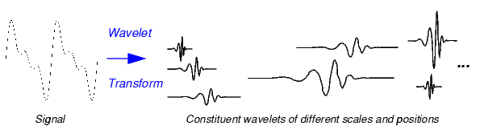
Fig.4.7 Wavelet Transform of a given signal

4.7.1.1 Scaling
‘Scaling a wavelet simply means stretching (or compressing) it.’
To go beyond colloquial descriptions such as "stretching," we introduce the scale factor, often denoted by the letter’α’. If we're talking about sinusoids, for example, the effect of the scale factor is very easy to see:
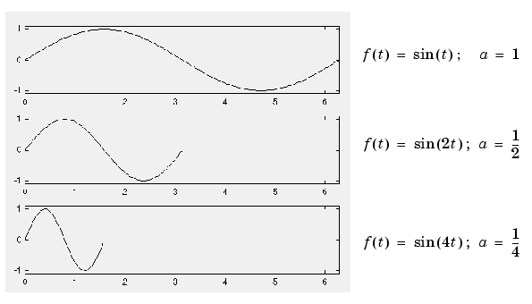
Fig.4.8 Scaling a wavelet-stretched case

The scale factor works exactly the same with wavelets. The smaller the scale factor, the more "compressed" the wavelet.
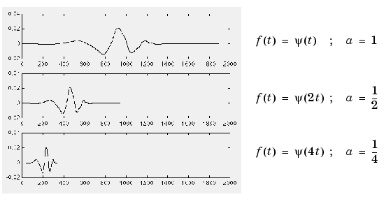
Fig.4.9 Scaling a wavelet –compressed case

4.7.1.2 Shifting
“Shifting a wavelet simply means delaying (or hastening) its onset.”
Mathematically, delaying a function Ψ(t) by k is represented by ω(t-k).
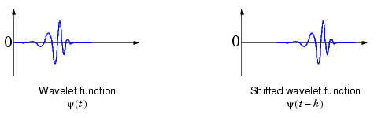
Fig.4.10 Shifting a Wavelet

4.7.1.3 Five Easy Steps to a Continuous Wavelet Transform:

The continuous wavelet transform is the sum over all time of the signal multiplied by scaled, shifted versions of the wavelet. This process produces wavelet coefficients that are a function of scale and position.
It's really a very simple process. In fact, here are the five steps of an easy recipe for creating a CWT:
1. Take a wavelet and compare it to a section at the start of the original signal.
2. Calculate a number, C, that represents how closely correlated the wavelet is with this section of the signal. The higher C is, the more the similarity. More precisely, if the signal energy and the wavelet energy are equal to one, C may be interpreted as a correlation coefficient. Note that the results will depend on the shape of the wavelet you choose.
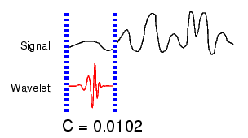
3. Shift the wavelet to the right and repeat steps 1 and 2 until you've covered the whole signal.
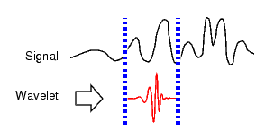

4. Scale (stretch) the wavelet and repeat steps 1 through 3.
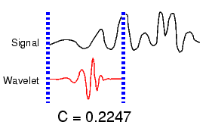

5. Repeat steps 1 through 4 for all scales.

4.7.2 Discrete Wavelet Transform

The application of wavelet transform in engineering areas usually requires discrete wavelet transform (DWT). The representation of DWT can be written as:
................... (4.7)
The Wavelet Series is just a sampled version of CWT and its computation may consume significant amount of time and resources, depending on the resolution required. The Discrete Wavelet Transform (DWT), which is based on sub-band coding is found to yield a fast computation of Wavelet Transform. It is easy to implement and reduces the computation time and resources required. The foundations of DWT go back to 1976 when techniques to decompose discrete time signals were devised. Similar work was done in speech signal coding which was named as sub-band coding. In 1983, a technique similar to sub-band coding was developed which was named pyramidal coding. Later many improvements were made to these coding schemes which resulted in efficient multi-resolution analysis schemes. In CWT, the signals are analyzed using a set of basis functions which relate to each other by simple scaling and translation. In the case of DWT, a time-scale representation of the digital signal is obtained using digital filtering techniques. The signal to be analyzed is passed through filters with different cut-off frequencies at different scales.

The use of the discrete Fourier transform (DFT) in signal analysis strictly requires a periodic signal. This, besides the limitation of the sampling frequency by the Nyquist sampling criteria, imposes two important restrictions when using the DFT in the analysis of power system transients. If a signal is altered in a localized time instant, the entire frequency spectrum can be affected. On the other hand, in short-time Fourier transform (STFT), a “time-frequency” window is used to localize sharp transitions. The STFT time window is fixed, however, and this method can be inadequate for accurate analysis of localized transient structures. A wavelet based signal-processing technique is an effective tool for power system transient analysis and feature extraction. A discrete wavelet transform (DWT) expands a signal not in terms of a trigonometric polynomial but by wavelet, generated using the translation and dilation of a fixed wavelet function. The wavelet function is localized in time and frequency yielding wavelet coefficients at different scales. This gives the wavelet transform much greater compact support for the analysis of signals with localized transient components. Unlike the STFT where the time period of each window is fixed, the DWT output can be represented in a two-dimensional (2-D) grid but with very different divisions in time and frequency so that the windows are narrow at high frequencies and wide at low frequencies.
4.8 Multi-Resolution Analysis (MRA)
MRA analyses the signal at different frequencies with different resolutions .It is designed to give good time resolution and poor frequency resolution at high frequencies and good frequency resolution and poor frequency resolution at low frequencies. This approach is useful especially when the signal has high frequency components for short durations and low frequency components for long durations.
A very useful implementation of DWT, called multi-resolution

Analysis is demonstrated in Fig. 4.11
Fig 4.11 Decomposition of a given signal

The original sampled signal x(n) is passed through a high pass filter h(n) and a low pass filter l(n). Then the outputs from both filters are decimated by 2 to obtain the detail coefficients and the approximation coefficients at level 1 (D1 and A1). The approximation coefficients are then sent to the second stage to repeat the procedure. Finally, the signal is decomposed at the expected level.
Fig 4.12 (a) & (b) Original signal and its Decomposed signal
In the case shown in Fig. 4.12 (a) & (b), if the original sampling frequency is F, the signal information captured by D1 is between F/4 and F/2 of the frequency band. D2 captures the information between F/8 and F/4. D3 captures the information between F/16 and F/8, and A3 retains the rest of the information of original signal between 0 and F/16. By such means, we can easily extract useful information from the original signal into different frequency bands and at the same time the information is matched to the related time period. An example, given in Fig. 4.12 (a) & (b), illustrates the procedure. The original signal is one cycle of a post-fault current signal, as shown in Fig. 4.12 (a). We use db5 wavelet to make a 5 level decomposition. The reconstructed versions of each detail and the approximation are shown in Fig. 4.12 (b). The information of original signal is clearly represented at each frequency band. The original signal can be reconstructed by adding up those wavelet signals at the same sample point. The wavelet toolbox in MATLAB provides a lot of useful techniques for wavelet analysis.
Fig 4.13 Frequency Spectrum

With reference to Fig. 4.13 and using a sampling frequency of 5.0 kHz, wavelets can be used to split the frequency spectrum according to specific frequency bands. In other words, the particular wavelet and sampling rate used to generate the output provides a meaningful decomposition of the transient into distinct power system signal phenomena, the highest-frequency impulse components appear in level 1( scale 1), and the bulk of energy in level 5 (scale 16), while the second- and third-harmonic components appear in level 4.

4.9 Wavelet Families
4.9.1 Haar
Any discussion of wavelets begins with Haar wavelet, the first and simplest. Haar wavelet is discontinuous, and resembles a step function. It represents the same wavelet as Daubechies db1.
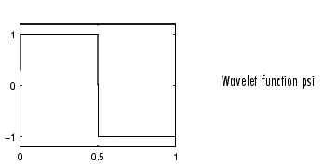
Fig.4.14 Haar Wavelet

4.9.2 Daubechies
Ingrid Daubechies, one of the brightest stars in the world of wavelet research, invented what are called compactly supported orthonormal wavelets -- thus making discrete wavelet analysis practicable.
The names of the Daubechies family wavelets are written dbN, where N is the order, and db the "surname" of the wavelet. The db1 wavelet, as mentioned above, is the same as Haar wavelet. Here are the wavelet functions psi of the next nine members of the family.
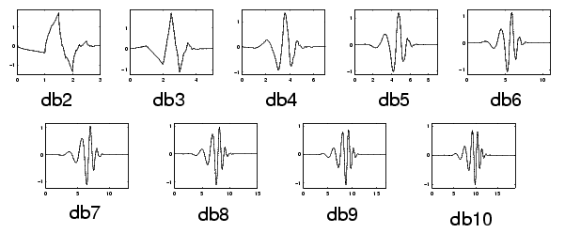
Fig.4.15 Family of Daubechies Wavelet
4.9.3 Biorthogonal

This family of wavelets exhibits the property of linear phase, which is needed for signal and image reconstruction. By using two wavelets, one for decomposition (on the left side) and the other for reconstruction (on the right side) instead of the same single one, interesting properties are derived.
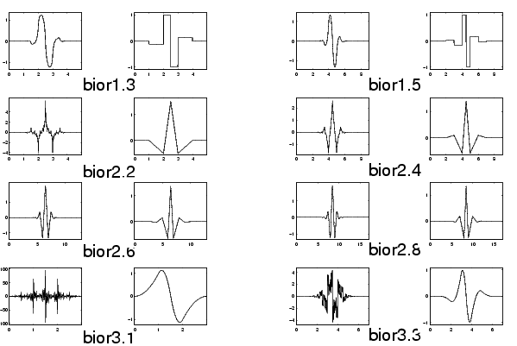
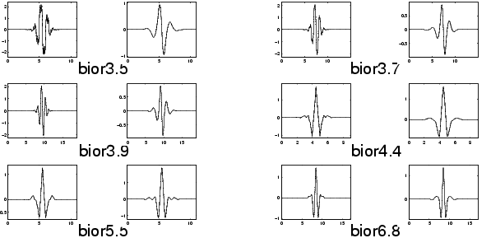
Fig.4.16 Family of Biorothogonal Wavelet
4.9.4 Coiflets
Built by I.Daubechies at the request of R.Coifman. The wavelet function has 2N moments equal to 0 and the scaling function has 2N-1 moments equal to 0. The two functions have a support of length 6N-1.

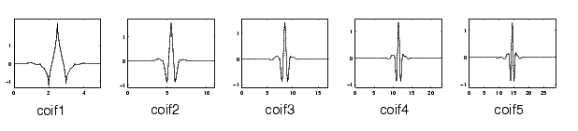
Fig.4.17 Family of Coiflets Wavelet
4.9.5 Symlets
The symlets are nearly symmetrical wavelets proposed by Daubechies as modifications to the db family. The properties of the two wavelet families are similar.
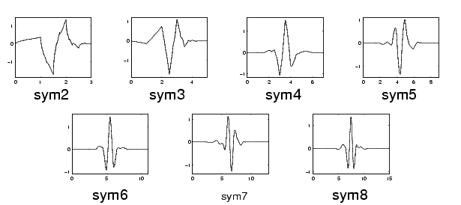
Fig.4.18 Family of Symlets Wavelet
4.9.6 Morlet
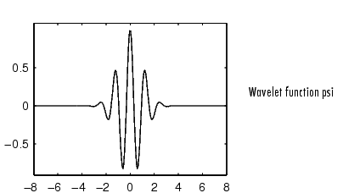
This wavelet has no scaling function, but is explicit.

fig.4.19 Morlet
4.9.7 Mexican Hat
This wavelet has no scaling function and is derived from a function that is proportional to the second derivative function of the Gaussian probability density function.
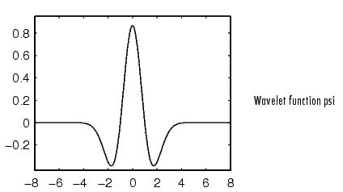
Fig.4.20 Mexican Hat Wavelet
4.9.8 Meyer
The Meyer wavelet and scaling function are defined in the frequency domain.
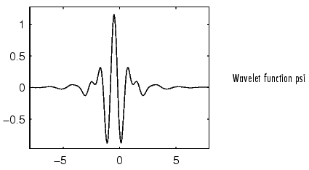
Fig.4.21 Mayer Wavelet
4.9.9 Other Real Wavelets
Some other real wavelets are available in the toolbox:
- Reverse Biorthogonal
- Gaussian derivatives family
- FIR based approximation of the Meyer wavelet
4.9.10 Complex Wavelets
Some complex wavelet families are available in the toolbox:
- Gaussian derivatives
- Morlet
- Frequency B-Spline
- Shannon
4.10 Applications Of Wavelets
There is a wide range of applications for Wavelet Transforms. They are applied in different fields ranging from signal processing to biometrics, and the list is still growing. One of the prominent applications is in the FBI fingerprint compression standard. Wavelet Transforms are used to compress the fingerprint pictures for storage in their data bank. The previously chosen Discrete Cosine Transform (DCT) did not perform well at Whigh compression ratios. It produced severe blocking effects which made it impossible to follow the ridge lines in the fingerprints after reconstruction. This did not happen with Wavelet Transform due to its property of retaining the details present in the data.
In DWT, the most prominent information in the signal appears in high amplitudes and the less prominent information appears in very low amplitudes. Data compression can be achieved by discarding these low amplitudes. The wavelet transforms enables high compression ratios with good quality of reconstruction. At present, the application of wavelets for image compression is one the hottest areas of research. Recently, the Wavelet Transforms have been chosen for the JPEG 2000 compression standard.
Fig 4.22 Signal Processing Application
Figure 3.23 shows the general steps followed in a signal processing application. Processing may involve compression, encoding, de-noising etc. The processed signal is either stored or transmitted. For most compression applications, processing involves quantization and entropy coding to yield a compressed image. During this process, all the wavelet coefficients that are below a chosen threshold are discarded. These discarded coefficients are replaced with zeros during reconstruction at the other end. To reconstruct the signal, the entropy coding is decoded, then quantized and then finally Inverse Wavelet Transformed.
4.10.1 Other Applications
Wavelets also find application in speech compression, which reduces transmission time in mobile applications. They are used in de-noising, edge detection, feature extraction, speech recognition, echo cancellation and others. They are very promising for real time audio and video compression applications. Wavelets also have numerous applications in digital communications. Orthogonal Frequency Division Multiplexing (OFDM) is one of them. Wavelets are used in biomedical imaging. For example, the ECG signals, measured from the heart, are analyzed using wavelets or compressed for storage.

CHAPTER -V

5. INDUCTION MOTOR SIMULATION DIAGRAM
5.1 Low Frequency T-Equivalent Induction Motor Model Per Phase:
The IEEE Standard 112 was established to obtain test methods and parameters for a low frequency (50, 60, and 400 Hz) per phase T-equivalent induction motor model in Fig.5.1 The rotor circuit and neutral are actually physically isolated from the line side stator neutral by the air gap in Fig. 5.1. Also, the rotor frequency (slip frequency) is different from the stator (or line) frequency. Users desire this low-frequency transfer function model to obtain the line side electrical quantities (frequency, current, power factor, and efficiency) for the given mechanical output quantities (power, horsepower, and torque).

Fig.5.1 IEEE 112 recommended per-phase low-frequency equivalent circuit.
5.2 Distributed High Frequency Π Model
The high-frequency response of the polyphase induction motor has recently been studied. High-frequency motor models can be mainly divided into two classes, i.e., distributed and lumped parameter models. The initial need concerned the analysis of high-frequency,high-magnitude surge effects on the utility-connected motor stator windings. Analysis methods typically include use of a distributed parameter model in Fig.5.2 to analyze the distribution of surge voltage within the winding.

Fig.5.2 Distributed high frequency model for stator winding.
5.3 Proposed per-Phase Universal Induction Motor Model
Motor behavior at steady-state conditions and low frequencies is best described by the well-known standard T-equivalent circuit in Fig 5.1.. In the low-frequency range, the voltage is distributed uniformly through the stator winding turns. In the medium-frequency range, the motor behaviour can be best represented by a distributed parameter model in which the impact of rotor circuit is negligible and the motor behaviour alternates between being capacitive and inductive. However, in this project, motor behaviour from 10 Hz to 10 MHz is studied.
In order to model the resonance and anti resonance frequencies, three capacitors Csf−effective, Csf−0, and Csw are proposed as additions to the T-equivalent motor model in Fig.5.1. to represent the mid-to-high frequency range of motor behaviour characteristics. Csf capacitance is the total stator-to frame capacitance. Csf−effective is the effective stator-to-frame capacitance of the first slot per phase in Fig. 5.3. Csf−0 is the stator-to-frame capacitance in the Y neutral. Csw capacitance is the stator interturn capacitance per phase.
Fig.5.3 Proposed per-phase universal induction motor model.

5.4 Proposed Three-Phase Universal Induction Motor Model
The mathematical model of the induction motor considered for simulation study is shown in Fig.5.4 The three phase Induction Motor is represented by a universal model which is valid for a wide range of frequencies. A three-phase, 5HP, 460V, 4pole Induction Motor with 36slots, 6coils per phase and 30 turns per coil is considered. Each coil of the stator winding is represented by a distributed π model as shown in Fig.5.2
.
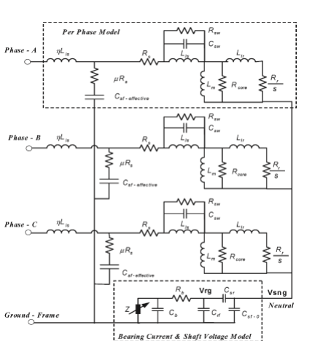

Fig.5.4 Proposed Three-Phase universal induction motor model with the addition of the bearing current–shaft voltage model to the stator neutral

5.4.1 Parameter Identification Procedure for Proposed Model
- Stator Resistance Rs:
To insure that the fundamental frequency (50, 60, or 400 Hz) current flow in the model results in correct output fundamental power and torque, the Rs value must be the manufacturer’s hot or cold resistance of the winding. Wire copper losses at harmonic frequencies, carrier frequency, and reflected wave ring frequencies must be accounted for in the Rsw damping term.
- Core Loss Resistance Rcore:
The standard 460-V 60-Hz four-pole motor Rcore values versus horsepower size were found to follow Rcore = 6300 (hp)−0.6958. The importance of Rcore is greater at higher horsepower, where it affects the terminal reflection coefficient by approaching the 50- to 120-Ω cable surge impedance values.
3) Rotor Resistance Rr, Rotor Inductance Llr, and Slip s:
By using the manufacturer T-equivalent circuit values as is for the proposed motor model. There is rotor inductance skin effect and deep bar skin effects of rotor resistance.
4) Magnetizing Inductance Lm:
It is noted that the effect of the magnetizing inductance is negligible since it is in parallel with the rotor leakage inductance .
5) Stator Leakage Inductance Lls:
The reduction of Lls inductance at harmonic and carrier frequencies is recognized to be a secondary effect. The term ηLls is used to account for the fact that only a fraction of the total stator leakage inductance is attributed to the high-frequency antiresonance point (∼3–10 MHz), specifically the first few turns in the first slot of the entry winding. Thus, ηLls is (the first few turns in the first slot/total turns per phase)2 × Lls. Winding data and machine geometry could be obtained from the manufacture.
6) Total Stator-to-Frame Capacitance per Phase Csf−total:
For frequencies greater than the first resonant frequency (fr1), the stator slot winding-to-frame capacitance (Csf−slot) plays an important role in describing the DM and CM motor behavior at high frequencies, while Csf−total plays a role in matching the CM transfer function at low frequency. Csf−total is calculated from the machine geometry by analyzing each slot capacitance to ground and multiplying by the number of stator slots. Each stator slot can be approximately considered as a rectangular-shaped conductor with Lstack stator length, wslot average width, and dslot average depth . For a motor with Nslot stator slots and a double-layer winding, the total stator winding to frame capacitance can be obtained as
Csf−total = (Nslot × Csf−slot)/2......................(5.1)
7) CM Stator-to-Frame Capacitance Csf−0:
Csf−0 is the remaining stator CM capacitance-toground lumped in the neutral Y. Accordingly, the following value is used in the proposed three-phase model:
Csf−0 = Csf−total − 3Csf−effective...............(5.2)
That a Δ-connection has twice Csf−slot compared to a Y-connection. Moreover, the number of parallel circuits may also change the effective stator-to-frame capacitance value Csf−effective.
8) Stator Turn-to-Turn Winding Capacitance Csw:
This parameter can be determined in a number of ways. One of the method the second resonance frequency is approximately twice or less than the first resonance frequency. That is, the interturn stray capacitance can be obtained as a function of Csf−effective,
Csw = (fr2/fr1)2Csf−effective.............(5.3)
9) Stator Turn-to-Turn Damping Resistance in Winding Rsw:
This term accounts for the skin and proximity effect of the wire and high-frequency core loss.It has been found that the core loss resistor Rcore does not have a significant impact on damping. Calculation of wire skin and proximity effects.The wire skin and proximity effect factors at the resonant frequency multiplied by the Rdc value results in a series value that could be converted to a parallel Rsw value.
10) Stator Initial Frame-to-Ground Damping Resistance μRs:
This component is the ac resistance of the fractional part of the total stator Rs due to the ηLls segmentation described. The 60-Hz μRs value is proportional to the stator resistance, and a multiplying factor of 10–20 is used for ac skin and proximity effects. In addition, it also encompasses the resistivity of steel laminations from the slots to where the motor ground wire in the junction box is connected. The term μRs affects the peak CM current as well as the damping of oscillations in the CM current to ground.

And the parameters are given by
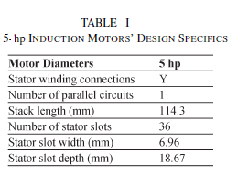

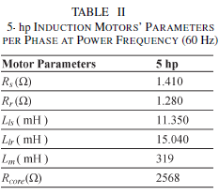

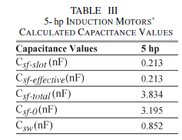
Table 5.1 Parameters of induction Motor.
And the value of R_{SW} per phase is considered as(11.867e3)Ω.

5.5 Simulation Diagram of Universal Induction Motor Model
The following Fig.5.5 shows the simulation model of a 3 phase induction motor model . The three phase Induction Motor is represented by a universal model which is valid for a wide range of frequencies. A three-phase, 5HP, 460V, 4pole Induction Motor with 36slots, 6coils per phase and 30 turns per coil is considered.
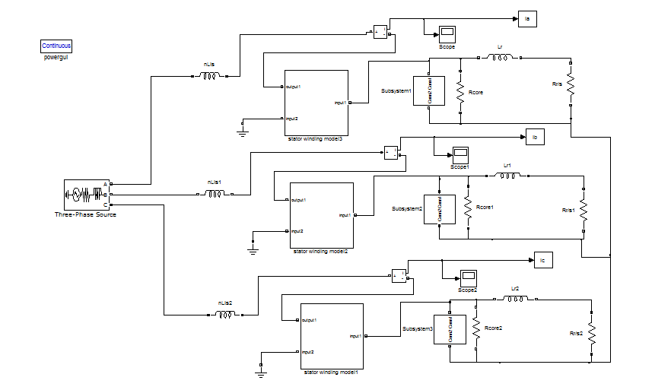
Fig.5.5 Simulation model of a 3 phase induction motor model

5.6 Case Studies
5.6.1 Inter Turn Fault
Stator faults are basically the breakdown of the winding insulation. This may be caused by excess thermal or voltage stress, mechanical vibrations, or an abrasion between the stator and the rotor. The weakness of the winding insulation can further result in the turn-turn short circuit, and eventually winding-ground and line to line short circuit.An Inter turn fault is incorporated in induction motor model by shorting appropriate number of turns. In this project the fault is carried out by shorting 4 in each phase individually by placing a circuit breaker across the turns.
And the fault is created at 4 th cycle, the simulation is carried out at every switching instant.And the detection is done with A1 coefficients by applying wavelets and classification with the energy of current signals from FFT.
  - Diagnosis Algorithm

- Extracting the a1 coefficients from original current signals.
- The absolute peak values of a1 coefficients for all the three phases set as a fault indices.
- Fault indication is based on fault indices which are lesser than the predefined threshold, otherwise there is no fault.
Fixing the threshold value by considering the minimum value under all fault cases and maximum value under healthy case.
FLOW CHART FOR FAULT DETECTION AND CLASSIFICATION:

Decompose the Phase currents using bior5.5 up to 1 level with fs=6 khz

Start

Obtain A1 coefficients

Is sum of lIal,lIbl,lIcl
>Threshold1

Yes N0
Fault

NO Fault

Calculate Absolute values

Is sum of Absolute value is >2965

Healthy
YES
NO
Inter turn Fault

End

FLOW CHART FOR FAULT DETECTION AND CLASSIFICATION:

Decompose the Phase currents using bior5.5 up to 1 level with fs=6 khz

Start

Obtain A1 coefficients

Is sum of lIal,lIbl,lIcl <Threshold2

NO YES
Fault
NO Fault

Calculate Absolute values

Is Absolute value is <9500

Healthy
L-G Fault

YES NO

END

Fig 5.6 :Flow chart for fault detection

CHAPTER -VI

6. SIMULATION RESULTS
Because of the facility to allow the use of variable window length, WT is useful in analyzing transient phenomena such as those associated with line faults and/or switching operations. Unlike FT, wavelet analysis has the ability to analyze a localized area of a signal and can reveal aspects of data like break points, discontinuities, etc. WT is thus useful in detecting onset of a fault and in realizing non stationary signals comprising both low and high frequency components.
Wavelet transform gives an adequate emphasis to depict the real-time implementation of fault detection and classification algorithm. Wavelets are mathematical tools for signal analysis. Wavelet analysis is particularly efficient where the signal being analyzed has transients or discontinuities, e.g., the post-fault voltage/current waveform.
In most power system relaying algorithms, the first step always involves fault detection followed by fault classification. For detection and classification of transmission line faults using wavelet multi resolution analysis (MRA) are based on measurements and comparison of sharp variation in the values of the currents for the three phases in the first stage MRA detail signals extracted from the original fault signals.
6.1 Fault Detection And Classification
Fault detection can be obtained from the details of the first decomposition level of the measured current signals using db5 wavelet. This level contains the high frequencies that are associated with faults. By calculating the peak absolute values of the detail coefficients (d1) for all the phase currents, the fault on the motor can be identified. If the calculated peak absolute value of all phases exceeds a certain threshold, then the motor is exposed to a fault. The type of fault ,can be determined by calculating the energy values of current signals under fault using FFT and defining a pre defined range of energy value for various faults.

Table 6.1(a): Approximation values for Interturn faults
Fault in PHASE A | APPROXIMATION | Ia | Ib | Ic | Threshold
Coil 1 | APPROX-1 | 2943.996 | 2994.535 | 3120.441 | 2965
Coil 2 | APPROX-2 | 2943.995 | 2994.535 | 3120.441 | 2965
Coil 3 | APPROX-3 | 2943.995 | 2994.535 | 3120.441 | 2965
Coil 4 | APPROX-4 | 2943.995 | 2994.535 | 3120.441 | 2965
Coil 5 | APPROX-5 | 2943.995 | 2994.535 | 3120.441 | 2965
Coil 6 | APPROX-6 | 2943.996 | 2994.535 | 3120.441 | 2965

Fault in PHASE B | APPROXIMATION | Ia | Ib | Ic | Threshold
Coil 1 | APPROX-1 | 3099.142 | 2923.483 | 3037.918 | 2965
Coil 2 | APPROX-2 | 3099.142 | 2923.483 | 3037.918 | 2965
Coil 3 | APPROX-3 | 3099.142 | 2923.483 | 3037.918 | 2965
Coil 4 | APPROX-4 | 3099.142 | 2923.483 | 3037.918 | 2965
Coil 5 | APPROX-5 | 3099.142 | 2923.483 | 3037.918 | 2965
Coil 6 | APPROX-6 | 3099.142 | 2923.483 | 3037.918 | 2965

Fault in PHASE C | APPROXIMATION | Ia | Ib | Ic | Threshold
Coil 1 | APPROX-1 | 3008.904 | 3078.47 | 2964.485 | 2965
Coil 2 | APPROX-2 | 3008.904 | 3078.47 | 2964.485 | 2965
Coil 3 | APPROX-3 | 3008.904 | 3078.47 | 2964.485 | 2965
Coil 4 | APPROX-4 | 3008.904 | 3078.47 | 2964.485 | 2965
Coil 5 | APPROX-5 | 3008.904 | 3078.47 | 2964.485 | 2965
Coil 6 | APPROX-6 | 3008.904 | 3078.47 | 2964.485 | 2965

Table 6.1(b): Approximation values for L-G fault
Fault in PHASE A | APPROXIMATION | Ia | Ib | Ic | Threshold
Coil 1 | APPROX-1 | 10343.09 | 2892.95 | 2918.524 | 7500
Coil 2 | APPROX-2 | 11085.39 | 2890.357 | 2921.082 | 7500
Coil 3 | APPROX-3 | 11959.88 | 2887.894 | 2923.523 | 7500
Coil 4 | APPROX-4 | 13008.29 | 2885.547 | 2925.86 | 7500
Coil 5 | APPROX-5 | 14288.69 | 2883.306 | 2928.094 | 7500
Coil 6 | APPROX-6 | 15896.81 | 2881.159 | 2930.243 | 7500

Fault in PHASE B | APPROXIMATION | Ia | Ib | Ic | Threshold
Coil 1 | APPROX-1 | 2890.093 | 10253.55 | 2924.933 | 7500
Coil 2 | APPROX-2 | 2892.493 | 10968.82 | 2922.572 | 7500
Coil 3 | APPROX-3 | 2894.787 | 11808.83 | 2920.332 | 7500
Coil 4 | APPROX-4 | 2896.983 | 12811.57 | 2918.193 | 7500
Coil 5 | APPROX-5 | 2899.089 | 14056.85 | 2916.146 | 7500
Coil 6 | APPROX-6 | 2901.115 | 15531.55 | 2914.179 | 7500

Fault in PHASE C | APPROXIMATION | Ia | Ib | Ic | Threshold
Coil 1 | APPROX-1 | 2892.839 | 2874.841 | 9781.718 | 7500
Coil 2 | APPROX-2 | 2890.412 | 2877.62 | 10453.8 | 7500
Coil 3 | APPROX-3 | 2888.09 | 2880.262 | 11241.85 | 7500
Coil 4 | APPROX-4 | 2885.867 | 2882.78 | 12179.62 | 7500
Coil 5 | APPROX-5 | 2883.733 | 2885.187 | 13317.37 | 7500
Coil 6 | APPROX-6 | 2881.68 | 2887.49 | 14719.83 | 7500
HEALTHY GRAPHS:
For D1 Coefficients:
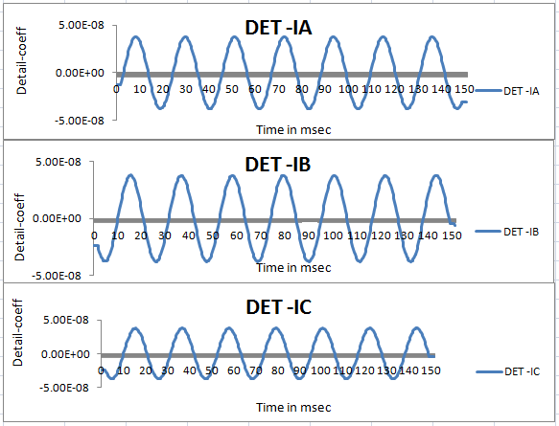Fig 6.1.1 For D1 Coefficient
For A1 Coefficients:
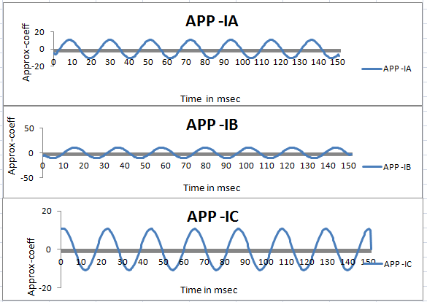
Fig.6.1.2 For A1 Coefficients
INTERTURN FAULTS
D1 Coefficients For An Interturn Fault In Phase A:
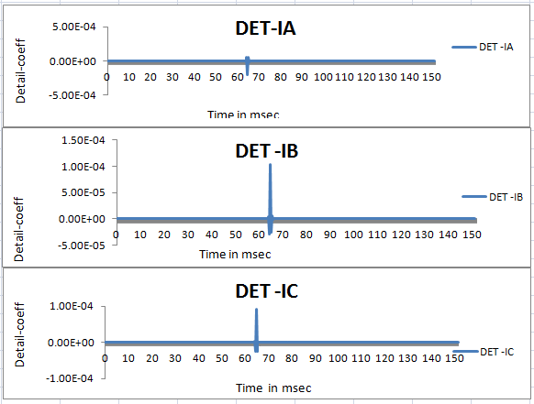
Fig .6.2.1 D1 Coefficients for an Interturn Fault in Phase A

A1 Coefficients for an Interturn Fault in Phase A :
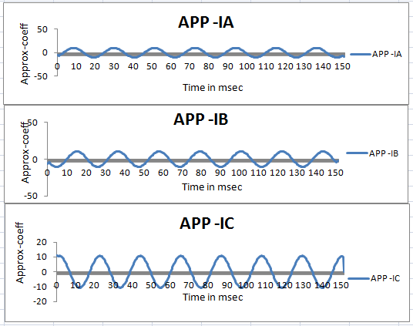
Fig .6.2.2 A1 Coefficients for an Interturn Fault in Phase A

D1 Coefficients for an Interturn Fault in Phase B :
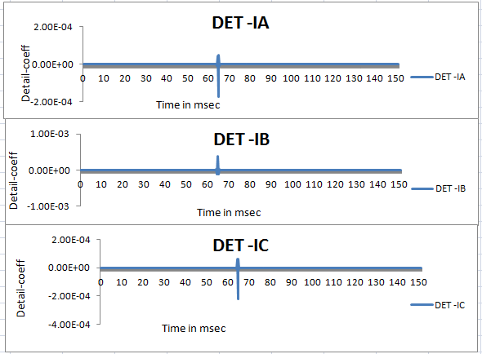
Fig .6.3.1 D1 Coefficients for an Interturn Fault in Phase B

A1 Coefficients for an Interturn Fault in Phase B :
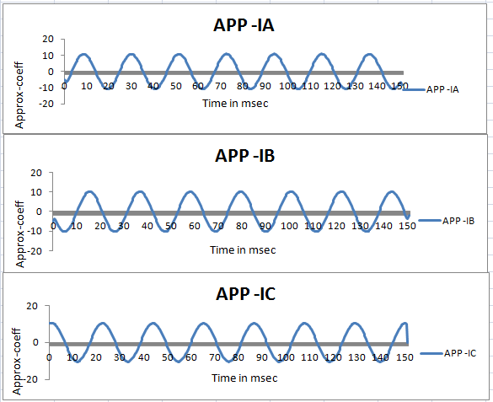
Fig .6.3.2 A1 Coefficients for an Interturn Fault in Phase B
D1 Coefficients for an Interturn Fault in Phase C:
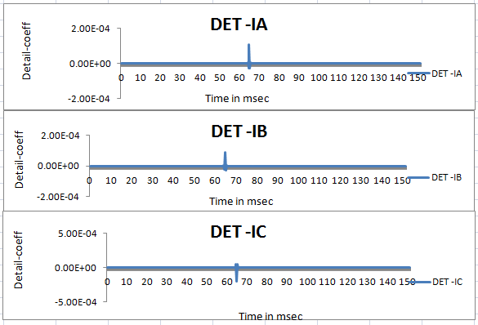
Fig .6.4.1 D1 Coefficients for an Interturn Fault in Phase C

A1 Coefficients for an Interturn Fault in Phase C :
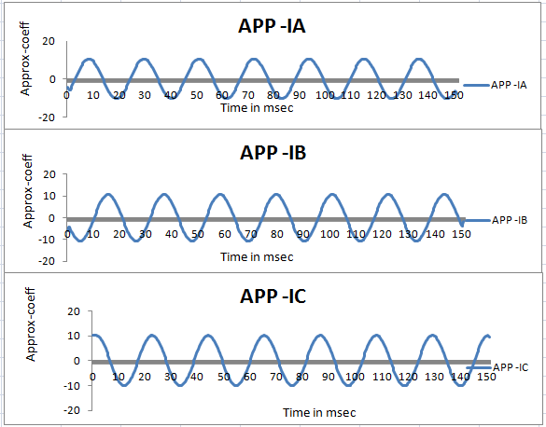
Fig .6.4.2 A1 Coefficients for an Interturn Fault in Phase C

D1 Coefficients for L-G Fault in Phase A :
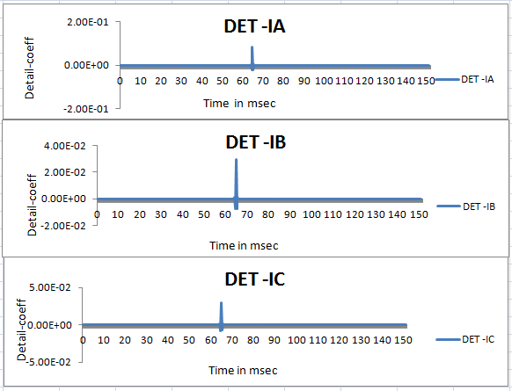
Fig .6.5.1 D1 Coefficients for L-G Fault in Phase A

A1 Coefficients for L-G Fault in Phase A :
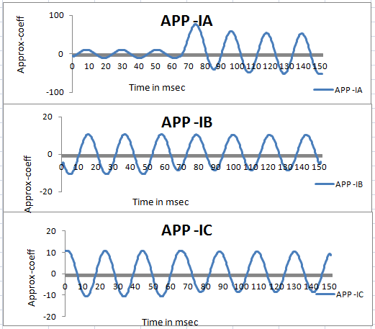
Fig .6.5.2 A1 Coefficients for L-G Fault in Phase A

D1 Coefficients for L-G Fault in Phase B :
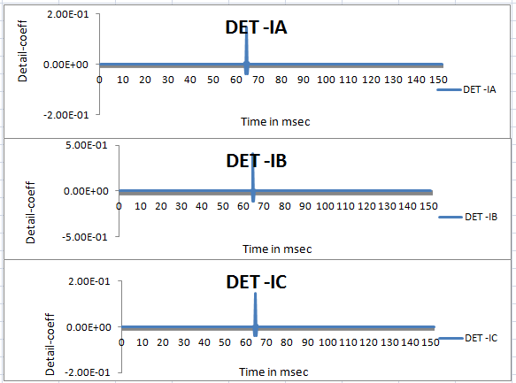
Fig .6.6.1 D1 Coefficients for L-G Fault in Phase B

A1 Coefficients for L-G Fault in Phase B:
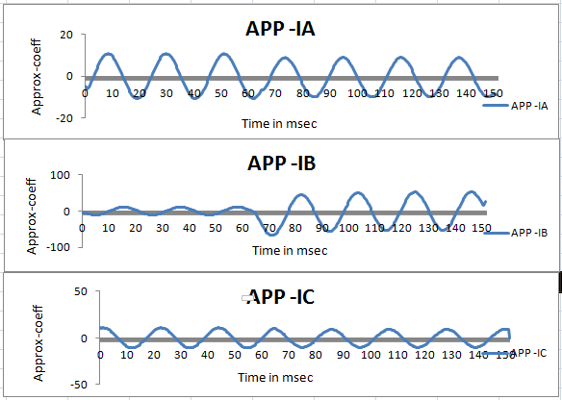
Fig .6.6.2 A1 Coefficients for L-G Fault in Phase B

D1 Coefficients for L-G Fault in Phase C:
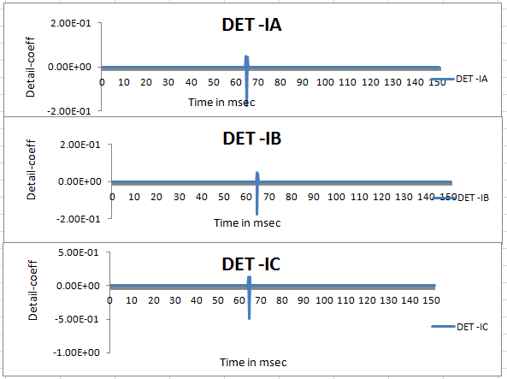
Fig .6.7.1 D1 Coefficients for L-G Fault in Phase C

A1 Coefficients for L-G Fault in Phase C :
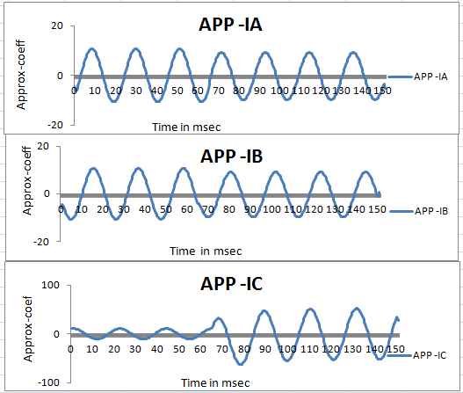
Fig .6.7.2 A1 Coefficients for L-G Fault in Phase C

Absolute Values in Case of Interturn Faults:
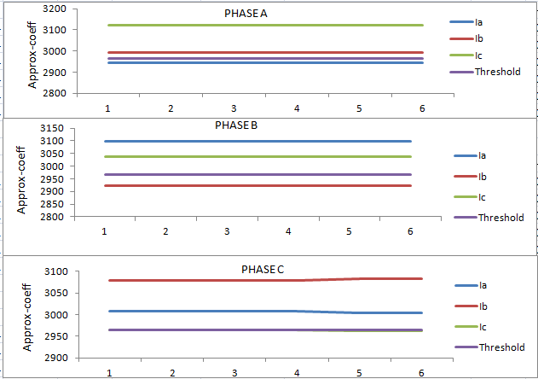
Fig.6.8.1 Absolute Values in Case of Interturn Faults

Absolute Values in Case of L-G Faults:

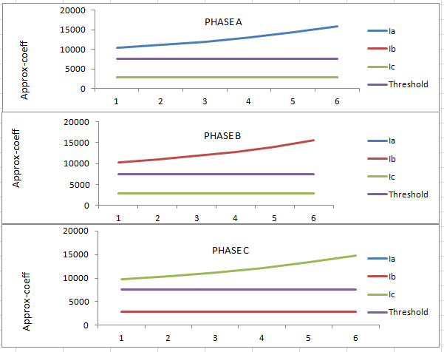
Fig.6.8.2 Absolute Values in Case of L-G Faults

Comparison Between Interturn & L-G Fault:
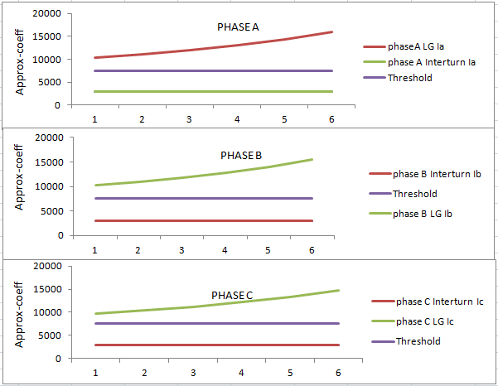
Fig.6.9 Comparision Between Interturn & L-G fault

CHAPTER -VII

7. CONCLUSION
The Proposed WT based diagnosis of faults on induction motor is simulated in the MATLAB simulation model and analyzed with different faults. The diagnosis of various faults on Induction motor has been done using the wavelet transform occurrence of faults.
The first level Approximation coefficients (A1) of bior5.5 extracted from original current signals are used for fault detection. The absolute values of original current signals are calculated for the fault classification. The type of fault to which a machine is exposed can be determined by comparing the obtained absolute value with the pre –defined range of absolute values for all faults.
Simulation results show that the proposed algorithm is found to be very fast and accurate for detecting and classifying various faults with different fault .
Since choice of particular wavelet plays a vital the superiority of bior5.5 wavelet over other standard wavelets for accurate fault detection. It seems to be promising for real-time fault detection using wavelets.

FUTURE SCOPE
- The investigations can be expanded by introducing stator fault types into a motor, and classification can be carried out.
- For large size motors, new challenges may exist, Therefore, proposed techniques may be applied for fault diagnosis of large size motors.
- The influence of gearbox components in the spectrum needs to be investigated.
- Additional work is needed to investigate the applicability of other signal processing tools.

REFERENCES
[1] Universal Induction Motor model with Low-to-high Frequency Response Characteristics by Behrooz Mirafzal, Gary Skibinski, Ranga Tallam David sehlegel and Richard lukaszewski.
[2] Aderiano M. da Silva, Richard J. Povinelli and Nabeel A. O. Demerdash, “Induction Machine Broken Bar and Stator Short-Circuit Fault Diagnostics Based on Three-Phase Stator Current Envelope,” IEEE Trans. Ind. Electron., vol. 55, no. 3, pp. 1310-1318, Mar. 2008.
[3] H. Douglas, P. Pillay, and A.K Ziarani, “A New Algorithm for Transient Motor Current Signature Analysis Using Wavelets,” IEEE Trans. Ind. Appl., vol. 40, no. 5, pp. 1361–1368, Sep/Oct. 2004,.
[4] M. E. H. Benbouzid et al., “Induction motors’ detection and localization using stator current advanced signal processing techniques,” IEEE Trans. Power Electron., vol. 14, no. 1, pp. 14–22, Jan.1999.
[5] T. W. S. Chow and S. Hai, “Induction machine fault diagnostic analysis with wavelet technique,” IEEE Trans. Ind. Electron., vol. 51, no. 3, pp. 558–565, Jun. 2004.
[6] W. Thomson and M. Fenger, “Current signature analysis to detect induction motor faults,” IEEE Ind. Appl. Mag., vol. 7, no. 4, pp. 26–34, Jul./Aug. 2001.
[7] Rahib Hidayat Abiyev and Okyay Kaynak, “Fuzzy Wavelet Neural Networks for Identification and Control of Dynamic Plants- A Novel Structure and a Comparative Study,” IEEE Trans. Ind. Electron., vol. 55, no. 8, pp. 3133–3140, Aug. 2008,.

[8] M. Awadallah and M. Morcos, “Application of AI tools in fault diagnosis of electrical machines and drives—An overview,” IEEE Trans. Energy Convers., vol. 18, no. 2, pp. 245–251, Jun. 2003.
[9] M. Ben Khader Bouzid, Gérard Champenois, Najiba Mrabet Bellaaj, Laurent Signac, and Khaled Jelassi, “An Effective Neural Approach for the Automatic Location of Stator Interturn Faults in Induction Motor” IEEE Trans. Ind. Electron., vol. 55, no. 12, pp. 4277-4289, Dec. 2008.
[10] H. Douglas, P. Pillay, and A. Ziarani, “Broken rotor bar detection in induction machines with transient operating speeds,” IEEE Trans. Energy Convers.,vol.20, no. 1, pp.135-141, Mar. 2005.
[11] A. R. Mohanty and C. Kar, “Fault detection in a multistage gearbox by demodulation of motor current waveform,” IEEE Trans. Ind. Electron. vol. 53, no. 4, pp. 1285–1297, Aug.
[12] Generalized Theory Of Electrical machines by Bimbhra.
[13] Electrical machine design by A.K.Sawhney.
[14] Wavelet tool box,Matlab 9.0,TheMathWorksIinc.,http://www.mathworks.com.
.

